Government College of Engineering, Jalgaon.
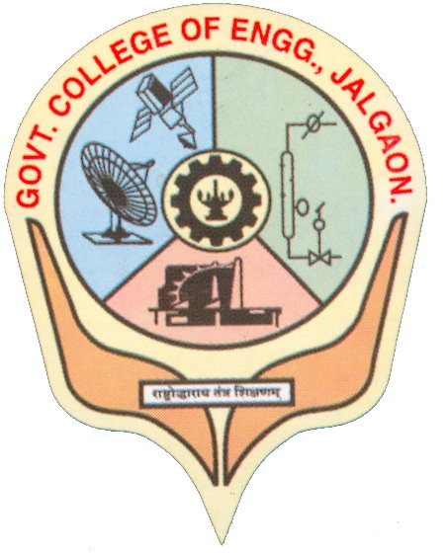
National Highway No. – 06, Jalgaon, Pin-425002.
Phone:02572281522; Fax 02572281319;
Web:www.gcoej.ac.in; email:princoej@rediffmail.com

Application for Provisional Degree Certificate

Photo
To,

The Dean Academics,
Government College of Engineering, Jalgaon - 425002
Signature
Respected Sir,
I request to issue me a provisional degree certificate as I have passed final year B.Tech./M. Tech. in ______________________________Engineering and paid the prescribed fees Rs ______
(in words Rs___________________________) vide receipt number__________ dated__/__/20__.
I am furnishing my details as given below.
Thanking You. Yours Faithfully,
Date : / / 20
Signature of the Candidate
Office Use only/Remark
Scholarship/Student Section Remark and Signature:

Registrar remark/approval and Signature:

Candidate’s Information.
1. | Name in Full as appeared on B. Tech / M. Tech marks statement  (In Capital Letters)
2. | Name in Deonagari script.
3. | Branch :
4. | Permanent Registration Number:
5. | Category: Caste and Sub-cast:
6. | Gender:
7. | Addhar No.
8. | Address for Communication  Mobile Number and e-mail
9. | Details of previous result
Year | Semester | Examination in which passed all courses | SGPA | CGPA | Audit Points earned in the semester.
 |  |  |  |  | (co-curricular) | (extra-curricular)
First | I | Winter/Summer/Re-examination 20____
First | II | Winter/Summer/Re-examination 20____
Second | III | Winter/Summer/Re-examination 20____
Second | IV | Winter/Summer/Re-examination 20____
Third | V | Winter/Summer/Re-examination 20____
Third | VI | Winter/Summer/Re-examination 20____
Fourth | VII | Winter/Summer/Re-examination 20____
Fourth | VIII | Winter/Summer/Re-examination 20____
Total Audit Points

Enclosure:
- Photo copies of all semester grade reports
- Photocopy of last year admission fee receipt

Date : / / 20 Signature of the Candidate

